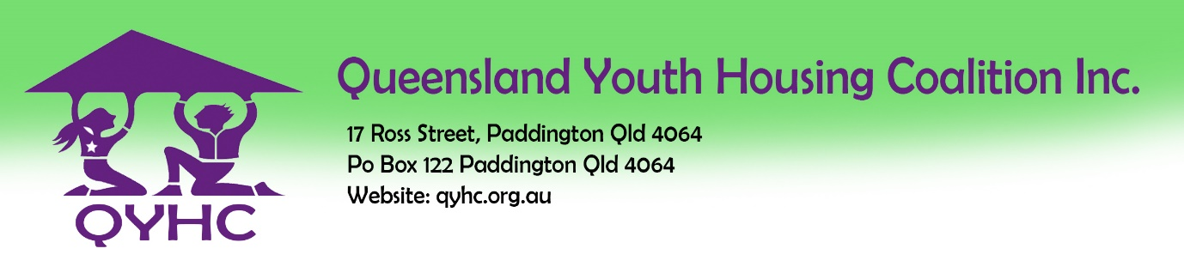

Platform 1225 Forum 2021

Expression of Interest - Express Platform Presentation

The Purpose of the Presentations:
As part of the Platform 1225 Forum on April 28th 2021, QYHC is calling for Expressions of Interest from organisations or individuals to share innovative programs, research or other developments relevant to the wellbeing of young people, with a particular focus on early intervention and prevention, collaboration and/or systemic reform, with the aim of improving the lives of children, young people, families and communities who face barriers to social inclusion.

The Express Platform Presentations will be 5-10 minutes in length and offer a brief snapshot of important work and innovation to be shared with the broad youth, family and community support sector and associated government and non-government organisations. These presentations are likely to include but are not limited to: child, youth and family support services as well as those working in mental health and drug and alcohol services; Aboriginal and Torres Strait Islander services; organisations focused on young people and families from a Culturally and Linguistically Diverse (CALD) background; organisations supporting Lesbian, Gay, Bisexual, Transgender, Intersex and Queer (LGBTIQ) young people, families and communities; services working alongside those with a disability and various education and training services.

Your details
- Name:
- Role:
- Email address:
- Organisation:
- Address of Organisation:

Proposed Platform Express Presentation

- What is the title of your presentation?
- What is the length of your presentation?
- Please provide an overview of your presentation in under 200 words. (This will be included in the Forum program):

- Please provide 3-5 dot points outlining the benefits and key messages delegates will gain from your presentation:

- Please list the names and organisations of all presenters of this Platform Express Presentation:

- Please include brief presenter biographies (max 100 words) for all presenters linked to this EOI:

Please send your completed EOI to:
Lorraine Dupree at: Lorraine.dupree@qyhc.org.au by March 17th, 2021.

All those who offer an Expression of Interest will be informed of the outcome by March 24th, 2021.

