Opening the Door Project
Project Information Sheet

What is the Opening the Door project about?
The Opening the Door project aims to support people with disability to achieve choice and control with their housing options. The project is for all people with disability regardless of their type of disability or age, and whether they are a participant in the NDIS or not.
The project is supporting people through a range of activities - holding forums, developing and bringing together resources, and through providing support to peer networks on housing issues. While there is an overlapping of these activities, you can engage with the project however suits. And if you think there is a knowledge gap to be filled, we are keen to see how we can assist. Importantly, through these activities the Opening the Door project will also identify some issues that warrant systemic advocacy, as well as further work by others.

Our Focus
The Opening the Door activities are based on the following four principles, each centred around the individual, guiding good housing outcomes for people with disability:
Rights: You have the same rights and responsibilities regarding your home as others.
Choice: You have a place you call home.
Inclusion: You are able to participate both socially and economically in mainstream society.
Control: The provision and management of housing is separate from the provision and management of paid support.
From these four principles, the Opening the Door project is focused on the following areas to help you on your housing journey:
- Living Arrangements - Clear Vision and Strong Ideas
  - How do I decide? Who helps me to decide?
  - Identification of where, how and with whom to live
- My Home - Housing Options
  - Identification of suitable affordable housing options and supports
  - Funding & financing – Government, NDIA and other opportunities
  - Goals & planning – decision making & risks
- Problem solving and finding help
  - Tenure & tenancy rights
  - Advocacy
  - Other assistance to help

Opening the Door project activities
Forums
A range of forums are being hosted through the Opening the Door project until at least September 2022. Some of these, such as the ACT Housing Solutions Innovation Group, will continue after that date. A schedule of forum dates can be viewed at https://riaustralia.org/‌opening-the-door-project/.
The forums are primarily intended for people with disability, their families, and carers.
Peer Networks
There is a broad range of established peer networks for people with disability throughout Australia. The Opening the Door project is able to engage with peer networks to discuss housing choices, and to assist peer network members to source information that can help them with their housing choices.
Where communities identify the need for the establishment of a new peer network focused on housing issues, we will do our best to assist.
Resources
For people with disability, their families, and carers, there is a lack of resources to assist with the navigation of the housing system. We have curated a range of resources to assist people to assist with their housing choices.
You can access resources at https://riaustralia.org/opening-the-door/useful-resources/.

Want to know more?
To find out more about the Opening the Door project , contact Rights & Inclusion Australia at projectofficer@riaustalia.org.au.

Project Partners
The Opening the Door project is being delivered by Rights & Inclusion Australia (R&IA) in partnership with National Shelter, the state & territory members of National Shelter, and Enliven Community (affiliated with Enliven Housing, based in Sydney).

Funding
The Opening the Door project is funded through the Australian Government’s ‘Individual Capacity Building’ grant program, overseen by the Department of Social Services.
This is part of the broader ‘Information, Linkages and Capacity-building’ response by the Australian Government to address the needs of people with disability in Australia.

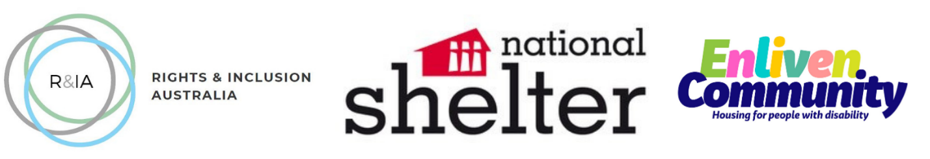

Queenslanders with Disability Network (2018). My Housing Matters: Housing matters for people with disability Workbook

