Initiative | Funding | Key messages | Image
Private rental assistance | $10 million | The Queensland Government is expanding access to private rental market assistance products to enable more Queenslanders to find private rental homes or maintain the tenancy they have. We’re starting by increasing income limits, to help more people access:  - Bond Loans  - Rental Grants  - Rental Security Subsidy  - Helping Hand Headlease  - RentConnect.  To find out if you’re eligible for private rental assistance, contact your local Housing Service Centre.  Call: 13 QGOV (13 74 68)  Visit: www.qld.gov.au/housing-service-centres | Photo: Customer and RentConnect officer at Logan HSC
Immediate Housing Response package | $26 million | Are you finding it hard to keep up with your private rental payments at the moment?  The expanded Rental Security Subsidy will help Queensland families stay in their home if they are experiencing or at risk of homelessness.  If you’re eligible, you can have your rent subsidised for up to 12 months. The total amount of the subsidy is based on your household income and individual circumstances.  Find out more about the Rental Security Subsidy: https://www.qld.gov.au/housing/renting/rent-assistance/security-subsidy  Talk to your local Housing Service Centre to see if the Rental Security Subsidy is right for you: https://www.qld.gov.au/housing-service-centres | Photo: two tenants and a baby, Toowoomba
Supporting tenancies | Over $11 million | The Queensland Government is supporting Queenslanders to sustain their private rental tenancies and stay in their homes by expanding tenancy sustainment services.  This includes additional homelessness support workers to help Queenslanders maintain their current tenancy by providing additional tailored support and brokerage funding for essentials.  You can call QSTARS (the Queensland Statewide Tenant Advice Services), a FREE high-quality advice and referral phone line to access up-to-date information about key tenancy issues, and advice to exercise your tenancy rights and responsibilities.  Vulnerable renters can also receive intensive support and resources for their tenancy situations.  If you need rental assistance, contact QSTARS on 1300 744 263. The line is open 9am-5pm Monday-Friday, with extended hours to 7pm on Tuesdays and Wednesdays.  If you need support with your tenancy, contact your local Housing Service Centre.  Call: 13 QGOV (13 74 68)  Visit: www.qld.gov.au/housing-service-centres | Photo: Housing officer and customer at Townsville HSC
Temporary emergency accommodation | $10 million | The Queensland Government is delivering more temporary emergency accommodation with onsite support by accessing underused accommodation.  We are continuing to look for opportunities to use commercial or alternative accommodation that is available to lease or purchase. This may include:  - hotels  - motels  - retirement and aged care facilities.  The funding will assist in securing this type of accommodation and providing a range of support services. Anyone at risk of, or experiencing homelessness, can contact the Homeless Hotline on 1800 474 753. | 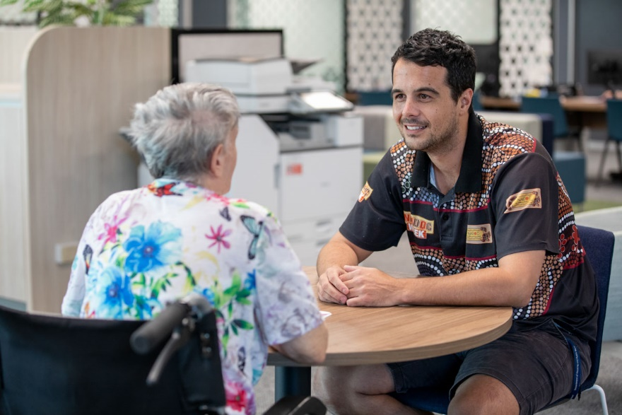  Photo: Customer and housing officer at Townsville HSC
Skillsets for Successful Tenancies | Ongoing | Many Queenslanders are needing support to find and keep their tenancy.  Skillsets for Successful Tenancies is a program to help people develop and improve their tenancy skills for the private rental market.  It’s a free 10-hour training package delivered through approved training partners. It focuses on:  - Budgeting  - Communication skills  - Cleaning and maintaining a rental property  - Understanding your rights and responsibilities as a tenant  Once you’ve finished the training, you’ll get a certificate that you can include in future rental applications.  Find out more about the program and how to enrol here: https://www.qld.gov.au/housing/renting/rent-assistance/skillsets | Photo: Tenancy training graduate
After-hours outreach | $8.5 million | The Queensland Government is ensuring people at risk of homelessness are connected to the services they need.  We’re expanding after-hours outreach services to support adults, families and young people who are experiencing homelessness and make sure they are connected to services available.  More outreach services are being delivered in:  - Brisbane  - Gold Coast  - Sunshine Coast  - Townsville  - Cairns.  Anyone at risk of, or experiencing homelessness, can contact the Homeless Hotline on 1800 474 753. | 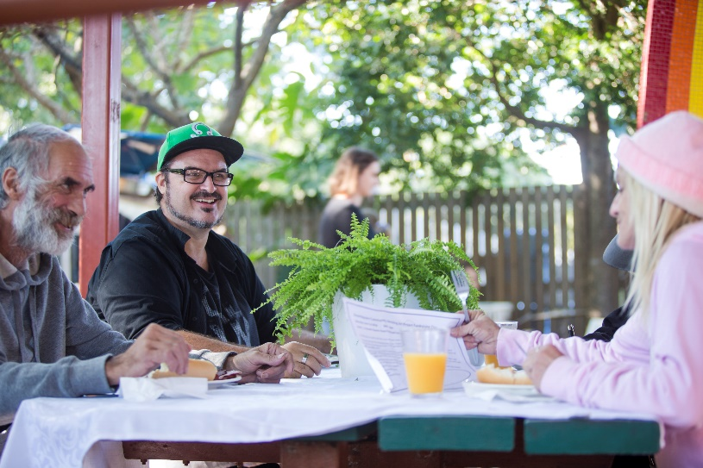  Photo: Worker and customers at Communify, New Farm
Emergency Relief | $2 million | If you or someone you know is going through a tough time and needs immediate support, there is help available.  The Queensland Government is funding emergency relief providers to help Queenslanders experiencing personal, family, relationship or financial issues.  Queenslanders in need can get help such as vouchers, food parcels and support with paying bills.  Emergency relief providers may also refer customers to other support services such as financial counselling and budgeting support. If you need help, contact your local Housing Service Centre.  Call: 13 QGOV (13 74 68)  Visit: www.qld.gov.au/housing-service-centres | 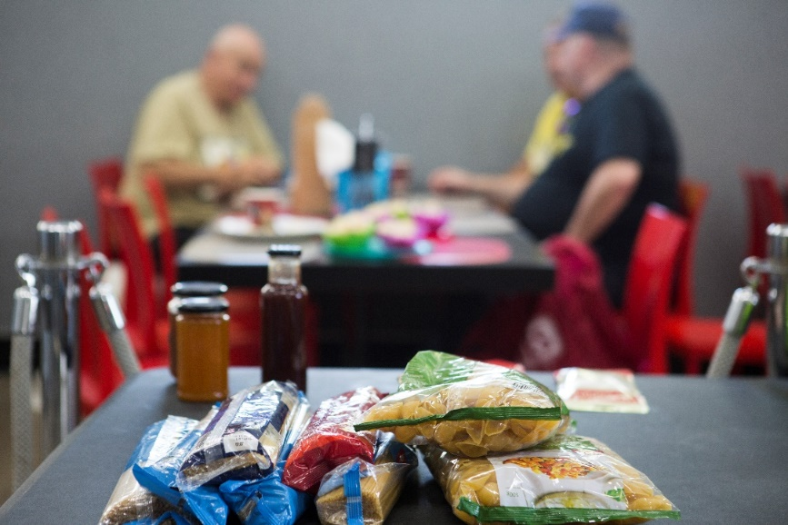  Photo: Havafeed, Gold Coast
Food relief | $1.3 million | We know many in our community are doing it tough right now and are struggling to get a meal on the table. And many who have not had to ask for help before.  If you or someone you know needs help, it is available.  The Queensland Government is partnering with Foodbank, OzHarvest and SecondBite to support Queenslanders in need with fresh food and meals delivered through breakfast programs, homeless shelter kitchens, food vans and neighbourhood and community centre food pantries.  Find food support at https://www.foodbank.org.au/find-food/?state=qld | Photo: Communify, New Farm

