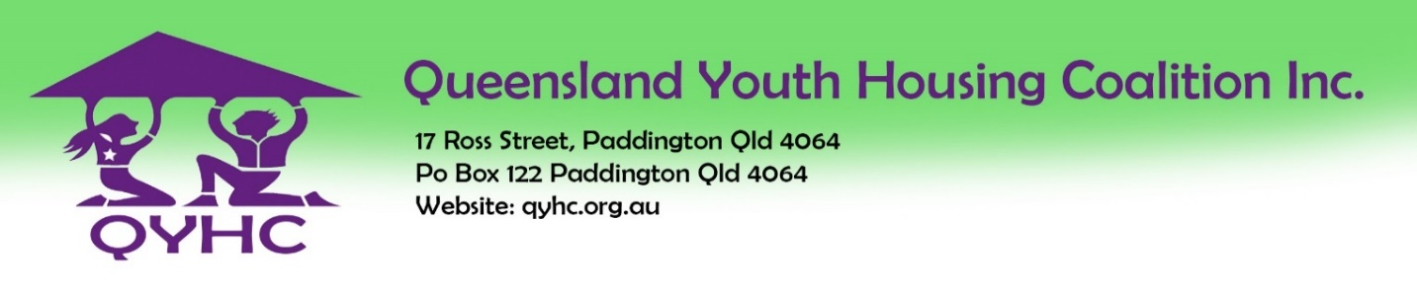

Membership Application

Individual Applicant Information
Name:
Phone: |  | Mobile:
Postal address:
City: |  | State: | Post Code:
Office address:
City: |  | State: | Post Code:
Email address:
Please tick |  | Un-employed/student: $2.00 |  |  |  | Individual: $5.00 | X

organisational Information
Name:
Phone: |  | Mobile:
Postal address:
City: |  | State: | Post Code:
Email address:
Please tick |  | Unfunded: $50.00 |  |  |  | Funded under $250,000: $150.00
Funded over $250 - $500,000: $250.00 |  | Funded $500,00-$1m: $300.00 |  |  |  | Funded over $1m: $350.00

Please tick if Payment has been made
Cheque: Queensland Youth Housing Coalition Inc.
Direct Deposit: Queensland Youth Housing Coalition Bendigo Bank BSB: 633-000 Account:121 157 077 |  |  |  |  |  |  | X

Signatures
On signing this document, I understand the Objects of the Queensland Youth Housing Coalition Inc. and I am authorized to apply for membership of QYHC.

The information provided on this form is true and accurate.
Signature of applicant: Date:

Office Use only
Date received:
Date accepted:
Secretary’s signature:
Membership fees paid: | Yes: |  |  |  | No:
 | Date of payment: |  |  |  | Form of Payment:

